SAFEGUARDING OF CHILDREN
Safeguarding the children in our care will always be of paramount importance to us. The children’s well-being is forefront in our minds and at the heart of everything we do.
Designated Safeguarding Lead (DSL): Lisa Gray
Deputy DSLs: Jessica Hammond, Emily Peussa, (Gemma Field-training will commence February 2019)
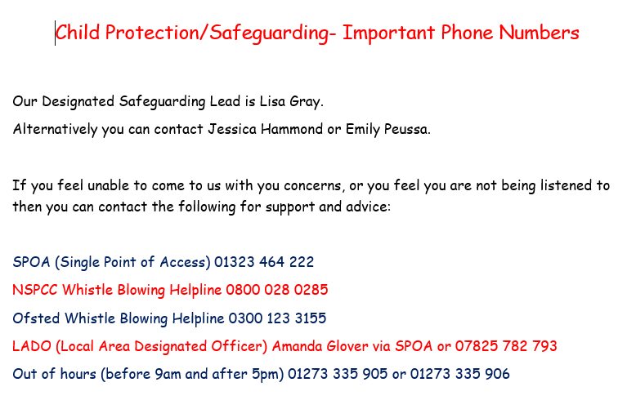

At Amberley we work with children, parent/carers, external agencies and the community to ensure the welfare of children and to give them the very best start in life. Children have the right to be treated with respect, be able to thrive and be safe from any abuse, in whatever form. We realise that safeguarding is a much wider subject then can be covered within a single policy, therefore this document should be read in conjunction with the nursery`s other policies and procedures, especially:
- Abusive Adults
- Camera and recording Devices
- Computers, Safe Storage, Disposal and Internet Safety
- Drugs and Alcohol
- Ill child
- Intimate Care
- Prevent Duty, Radicalisation and Promoting British Values
- Safe Care and Appropriate Use of Physical Comfort
- Social Networking and Mobile Devices
- Staff Working with Their Own Children and Those of Close Friends
- Students and Apprentices
- Uncollected Child
Our policy has been reviewed with local policies in mind, as well as giving full regard to the following legal frameworks:
- Children act 1989 and 2004.
- Children Act 2006
- Safeguarding Vulnerable Groups Act 2006
- Children and Social Work 2017
- The Statutory Framework for the Early years Foundation Stage (EYFS) 2017
- Working together to safeguarding children 2018
- What to do if you`re worried about a child being abused 2015
- Counter- Terrorism and security Act 2015.
- Keeping Children Safe in education 2018
- Data Protection Act 2018
Working Together to Safeguard Children 2018 defines safeguarding and promoting the welfare of children as:
- Protecting children from maltreatment
- Preventing the impairment of children’s health or development
- Ensuring that children are growing up in circumstances consistent with the provision of safe and effective care
- Taking action to enable all children to have the best outcomes
We will:
- Create an environment where children are encouraged to develop a positive self-image
- Provide positive role-models and develop a safe culture where staff are confident to raise concerns about professional conduct
- Discuss safeguarding and whistle blowing at every staff meeting, supervision and appraisal
- Always be ready to listen to the concerns of staff
- Support staff to notice the signs of abuse and know what action to take
- Encourage children to develop a sense of independence and autonomy in an age-appropriate manner
- Help children to learn they can say “no” and ask others to stop if they do not like something
- Provide a safe and secure environment where children are always listened to
- Promote tolerance, acceptance and celebration of all beliefs, cultures and communities
- Encourage staff and children to work together in decision making
- Encourage and support practitioners confidence to identify where children and families may need intervention and how to seek help
- Share information with other agencies as appropriate. Safeguarding of children will always supersede data protection.
Amberley nursery is aware that, unfortunately, child abuse does occur in our society and we are vigilant in identifying signs of abuse and reporting concerns. Our staff have a duty to protect and promote the welfare of children. Due to the many hours of care we are providing, staff may often be the first people to identify that there may be a problem. They may well be the first people in whom children confide information that may suggest abuse or to spot changes in a child`s behaviour which may indicate abuse. Our prime responsibility is the welfare and well-being of each child in our care. As such we believe we have a duty to the children, parents and staff to act quickly and responsibly in any instance that may come to our attention. This includes sharing information with any relevant agencies such as local authority services for children`s social care, health professionals or the police. All staff will work with other agencies including as part of a multi-agency team, where needed, in the best interests of the child.
The nursery aims to:
- Keep the child at the centre of all we do.
- Ensure staff are trained right from induction to understand the child protection and safeguarding policy and procedures, are alert to identify possible signs of abuse (including the signs known as softer signs of abuse) , understand what is meant by child protection and are aware of the different ways in which children can be harmed, including by other children through bullying or discriminatory behaviour.
- All staff will complete the local authority e-safeguarding as part of their induction period. Each practitioner is entitled to local authority child protection training once in their early years career, following this Amberley Nursery will ensure that practitioner’s knowledge and understanding is updated at least annually.
- Be aware of the increased vulnerability of children with Special Educational and Needs and Disabilities (SEND) and other vulnerable or isolated families and children.
- Ensure that all staff feel confident and supported to act in the best interest of the child, share information and seek the help that a child may need.
- Make child protection referrals in a timely manner, sharing relevant information as guided by East Sussex LCSB.
- Share information only with those that need to know in order to protect the child and act in their best interest
- Identify and respond to changes in staff behaviour
- Take action relating to allegations of harm or abuse, including reporting to OFSTED, LADO or SPOA.
- Support children by offering reassurance, comfort and sensitivity.
- Give staff have been given contact details for local and national agencies so they can report concerns if they feel unable to speak to a DSL or DDSL within nursery or feel their concerns are not being acted upon.
Absence Procedure
Parents/carers are asked to call or text to let us know if their child is going to be absent. This is not intended to stop families having precious time together, but enables us to log attendance and check children are safe.
For unexpected absences, where no contact has been made from the parents, practitioners text or call parents at 10am (or 3pm for an afternoon session), to enquire about the child’s whereabouts.
If no response has been received within one hour, practitioners must alert the DSL/DDSL.
The safeguarding lead for that day will again try to call the parents, then the child’s emergency contacts. If no response has been received then the DSL or DDSL will contact SPOA by phone.
Monitoring Children’s Attendance
We are required to monitor all children’s attendance patterns to ensure they are consistent and not a cause for concern.
Where children have a child protection or child in need plan, any absences will be reported to their social worker. If the social worker is unavailable, SPOA will be contacted.
Types of Abuse
There are many different forms of child abuse and the indicators of these may differ.
Types of child abuse:
- Peer on peer
Peer on peer abuse will be reported in the same way as adult to child abuse. Due to the young nature of the children within our setting, we are likely to only experience peer on peer abuse when perpetrated by a child outside of our setting.
- Physical abuse
Physical abuse includes deliberate poisoning, bruising or injuries in an area that is not usual for a child, e.g. fleshy parts of the arms and legs, back, wrists, ankles and face, burns, scalds, smacking, throwing. and where there is knowledge or reasonable suspicion that someone inflicted the injury or knowingly didn’t prevent it.
- Female Genital Mutilation (FGM)
Our lead person for FGM is the DSL.
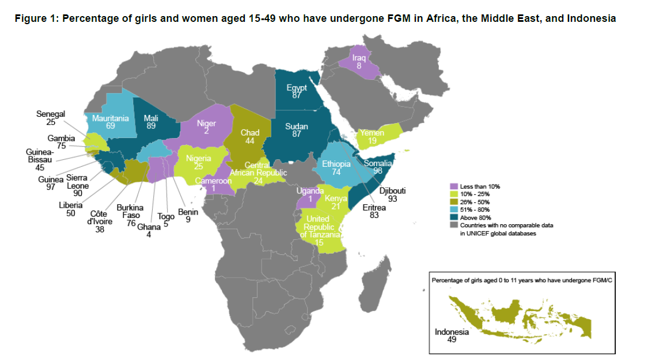

FGM is practised as a cultural ritual by some ethnic groups, it is not a religious practice. FGM may be carried out shortly after birth or childhood. Symptoms may include bleeding, pain to the intimate areas, urinary retention, urinary infection, wound infection, septicaemia, incontinence, depression, PTSD and even death. There is a mandatory duty to report all suspected cases of FGM to a person under 18 and we will always seek to do this when we have concerns FGM may be, or has been, committed.
Free training on FGM can be accessed at: www.fgmelearning.co.uk
Resource packs are available at: https://www.gov.uk/government/publications/female-genital-mutilation-resource-pack
The NSPCC has a free phone helpline for FGM concerns: 0800 028 3550
- Breast Ironing
Also known as breast flattening is the process where young girls breasts are massaged, ironed or pounded with hard and heated objects to prevent or delay breast development. It is believed in some cultures that by carrying out this act, young girls will be protected from harassment and rape. We recognise that it is unlikely to happen to children within our care, due to their young age, however we will be vigilant for whole families and report any concerns if they arise.
- Fabricated Illness
Is also a type of physical abuse. The parent/carer may seek out unnecessary medical treatment or investigation, exaggerate real symptoms or induce a physical illness, e.g. through poisoning, inappropriate diet, starvation. This can also be presented through false allegations of abuse or encouraging the child to act disabled or ill to obtain unnecessary services or support.
- Sexual Abuse
Young children may display sexual activity in a variety of ways, including speech, roleplay, drawing, having an excessive preoccupation with sexual matters or an inappropriate knowledge of sexual behaviour or language. This may include acting out sexual activity on dolls, toys or peers, drawing pictures which are inappropriate for a young child, talking about sexual activity or using sexual words. The child may become worried when their clothes are removed for personal care. Physical symptoms could include trauma to the genitals, discharge or bruises between the legs, signs of a sexually transmitted disease. Emotional symptoms could include a distinct change in behaviour. The child may be withdrawn or overly extroverted and outgoing. They may withdraw away from a particular adult and become distressed if they reach out for them. However they may also be particularly clingy to a potential abuser so all signs and symptoms should be looked at together as a whole.
- Child Sexual Exploitation (CSE)
Is a form of sexual abuse. It occurs where an imbalance of power is used to coerce, manipulate or deceive a person under the age of 18 into a sexual activity, in exchange for A) something the victim needs or wants, or B) for the financial advantage or increased status of the perpetrator.
- Emotional Abuse
Emotional abuse is when persistent or severe ill treatment or rejection results in severe, adverse effects on the behaviour or emotional development of a child. This can include extremes of discipline where a child is shouted at or put down on a consistent basis, lack of emotional attachment by a parent, or adults placing inappropriate expectations onto a child. Children witnessing domestic, drug or alcohol abuse by the adults caring for them may also be emotional abuse. The child is likely to display extremes of emotion with this type of abuse. It can be harder to identify as there are may be no physical signs.
- Neglect
This includes exposure to any kind of danger, cold, starvation, failure to seek medical treatment which results in serious impairment of the child’s health or development, including failure to thrive. Signs may include a child arriving dirty or unkempt, clothes and shoes which are too small, persistent hunger, arriving in a dirty nappy repeatedly, having an illness, disability or special need that is not being addressed by the parent. Neglect can also have emotional signs, children may crave love and attention, clingy and emotional. Neglect can also occur in pregnancy as a result of maternal substance misuse.
- Domestic Abuse, Honour Based Violence (HBV) and Forced Marriage
Are all child protection concerns.
Possible indicators may include:
- Failure to thrive and meet developmental milestones
- Fearful or withdrawn tendencies
- Unexplained or repeated injuries
- Conflicting reports about injuries
- Unaddressed illnesses or injuries
- Significant changes to behaviour patterns
- Unusual or sexual behaviours displayed within play
(The following are described as softer signs of child abuse by NICE)
- Low self-esteem
- Wetting and soiling
- Recurrent nightmares
- Aggressive behaviour
- Withdrawing communication
- Habitual body rocking
- Indiscriminate conflict or affection seeking
- Over-friendliness towards strangers
- Excessive clinginess
- Persistently seeing attention
Procedure for a child making a disclosure of abuse:
- The adult should reassure the child and listen without interrupting
- The practitioner must speak to the DSL without delay
- The practitioner will record their concerns accurately, noting if information is ‘in their opinion’, hearsay or fact. Details of injuries/marks are to be accurately recorded, including size, shape, colour and accurate location. Practitioners are to ensure wither incident records or welfare concern forms are used.
- The DSL will decide what action to take based upon the severity of the concern. They may refer the matter to SPOA or speak to the parent and keep a record in the safeguarding file. If the DSL has any doubt about the action they should take, they must seek advice from either SPOA or the key person service manager (01424 726790, option 2). If it is felt that speaking to the parent/carer may further endanger the child, then a referral should always be made.
- If the matter relates to a member of staff, the DSL will also contact OFSTED and LADO to report the concern.
- If there is concern that a child is in immediate danger, the police can be contacted on 999.
- If the child already has a social worker involved, it may be appropriate for the DSL to contact them directly rather than SPOA. If for any reason they are unable to contact the child’s social worker, SPOA must be contacted.
- The DSL will contact the child’s parents, unless they have been advised not to by one of the services mentioned above.
- THE DSL will follow up with the local authority children’s social care team if no response is received. Working Together to Safeguard Children (2018) gives advice on recommended time-scales for responding to safeguarding concerns.
- The DSL will record all actions they have taken and the outcomes of these.
- All members of staff will be expected to liaise and comply with any external agencies involved in the investigation. They must not disclose any information publically.
In the unlikely event that neither the DSL nor DDSLs can be contacted, the staff member with the concern MUST use the contact numbers at the beginning of this page to report their concerns themselves. TNEY MUST NOT TAKE NO ACTION AT ALL.
Storage of safeguarding records:
In line with our data audit, safeguarding records are stored in a locked filing cabinet in the office which is kept locked overnight. Keys are held by the DSL and DDSL. When a child leaves Amberley their records are passed on to their next setting, either by recorded mail or in person and a signed receipt is obtained. If a child goes on to home schooling we will retain their records.
Confidentiality:
All suspicions, enquiries and investigations are kept confidential and shared only with those who need to know to help protect the child.
Safeguarding records are only shared with a parent or carer with guidance of the local authority, with the child’s care and safety always being paramount.
Staff training:
As part of their induction, all staff members will complete the East Sussex online safeguarding training. They can access the LSCB practitioner child protection training once in their career and will be given safeguarding updates as a minimum annually in-house. Additionally child protection is discussed as part of every staff meeting, supervision and appraisal meeting.
We have a safeguarding display board which is updated as our setting receives information. We also put up relevant serious case reviews for practitioners to read.
As part of induction all staff members are given the contact details for SPOA, NSPCC, LADO, OFSTED and the out of hour’s service. These numbers are also displayed in the kitchen, hallway and downstairs office. Staff are asked to read the whistle blowing policy at least annually.
The DSL will attend LSCB designated safeguarding lead training every 2 years. The DSL will also attend Advanced Safeguarding and Train the Trainer.
Support to families:
Amberley aims to build trusting and supportive relationships between children, families and staff. We will continue to welcome the family and child whilst investigations are ongoing. All parties will be treated in a non-judgemental manner.
Allegations against adults working or volunteering with children:
The allegation should be reported to the DSL without delay. If the DSL is the subject of the allegation, another member of the safeguarding/management team should be contacted without delay:
Lisa- XXXXXXXXXXX
Jess- XXXXXXXXXXX
Mark- XXXXXXXXXXX
Emily- XXXXXXXXXXX
The DSL will:
- Contact LADO
- Contact OFSTED
- Contact SPOA (if appropriate)
- Contact the police (if appropriate)
- Carry out a full investigation under the guidance of LADO
- Follow all instructions given by LADO and OFSTED and expect all staff members to co-operate
- Suspend staff members involved in the investigation if it is appropriate to do so. Guidance will be sought from LADO if there is any uncertainty.
- Keep full and accurate records and store these securely (see Data Audit)
- Keep all records until the employee reaches retirement age or for 21 years if that is longer. This ensures accurate information is available for future reference requests.
Unfounded allegations will result in all rights being reinstated.
Founded allegations will be passed on to the relevant organisations, and, where an offence has believed to have been committed, to the police. All founded allegations of abuse will result in termination of employment, OFSTED and DBS will be notified of this decision on the same working day.
Counselling will be made available for any member of the nursery who is affected by an allegation, their colleagues or the child’s parents.
Looked after children:
As part of our commitment to safeguarding all children, we ask that we are informed of:
- The legal statues of the child (e.g. whether the child is begin looked after under voluntary arrangements or an interim or full care order.)
- Contact arrangements for the biological parents (or those with parental responsibility)
- The child’s care arrangements
- The details of the child’s social worker and any other support agencies involved, including their contact at the Virtual School
- Any child protection or child in need plan in place
Staff and volunteers:
Only adults who hold an enhanced DBS check will be left unsupervised with children, this includes all staff and regular volunteers. Although under EYFS guidance we are only required to have one designated lead for safeguarding, for best practice and to ensure cover at all times, we currently have 2 DDSL, with another due to commence training in February 2019. Safeguarding is a high priority for all staff at all times and there will always be a DSL or DDSL contactable, usually they will be on the premises, to ensure prompt action can be taken when concerns arise.
Applicants for posts within our nursery are informed that positions are exempt from the Rehabilitation of Offenders Act 1974. Candidates are informed of the need to carry out checks before posts can be confirmed. Where applications are rejected because of disclosed information, applicants have the right to know and challenge information they believe to be incorrect. A minimum of two references will always be obtained. Staff members are required to read the employees handbook as part of their induction, which contains details of our capability, disciplinary and grievance procedures.
All staff members who join Amberley after January 2019 will be required as part of their employment contract to be on the DBS update service. This service will be checked (as a minimum) as part of the staff members appraisal. We abide by the requirements of the Safeguarding Vulnerable Groups Act 2006 and the Childcare Act 2006 in respect of reporting anyone who is dismissed from our employment for safeguarding concerns, or resigns in circumstances that would otherwise have led to dismissal.
We conduct regular peer on peer and management observations to ensure that the care we provide for children is at the highest level, share constructive feedback, develop practice, build trust and identify any areas for staff development.
Staff members and volunteers are given regular opportunities to disclose changes that may affect their suitability to work with children as part of their supervision meetings. These may include changes to health, medication or in their home life, such as child protection plans for their own children.
Any changes in behaviour will be investigated, this could include changes in mood, sudden change in religious or cultural beliefs, changes manner towards other staff members or to the children, sudden outbursts, becoming withdrawn, secretive behaviours, missing shifts or calling in sick more frequently, work standards slipping, extreme changes to appearance, staff becoming overly domineering of other staff, where there is any concern surrounding peer on peer bullying.
Where there is a concern about staff behaviour an immediate meeting will be called with the individual and a member of management, to ascertain how the staff member is feeling. We will aim to support the staff member wherever possible. We aim to ensure staff are able to continue working with children as long as they are suitable to do so, however if behaviours cause concern about the safety or welfare of the children then safeguarding procedures will be followed and LADO will be informed. All conversations, observations and notes will be recorded and remain confidential.

Policy revised January 2019 Lisa Gray

